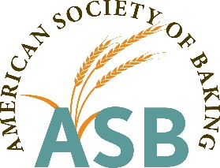

2019-20 Engineering and Maintenance/ Machinist Employee Scholarship Application

NAME: ____________________________________________________________________________________
First Last

_________________________________________________________________________________________
Street Address

______________________________ __________________ _________________________________________
City State Zip

__________________________________ ___________________________________________
Cell Phone email

______________________________________________ ___________________________
Trade/Vocational School/College/University Beginning/Ending Dates

______________________________________________ Enrolled for next semester? Yes / No
Course of Study

Work Experience
Employer’s Name | Position Held | Description of Responsibilities | Start/End Dates

Education (post high school)
Name of school | Years Attended | Degree or certificate received
Short Essay Questions – Please answer each question individually – application will not be accepted without the essays.
- Why have you chosen this area of work?
- What difference do you feel you can make/are making in the wholesale baking industry?
- How will additional education make you a better baking industry employee and how will it affect your current job and future career opportunities?
- What are your future career plans?
- Why do you feel you should be selected as a recipient of this scholarship?
- Is there any additional information you would like to share?

Additional Documentation
  - Submit a letter of recommendation from your direct supervisor.
  - Submit an official school transcript (if currently enrolled).

Application and supporting documents must be mailed or emailed by June 1, 2019.
Kent Van Amburg
Executive Director
American Society of Baking
7809 N Chestnut Avenue
Kansas City, MO 64119
609-937-1519 (Questions)
kvanamburg@asbe.org

