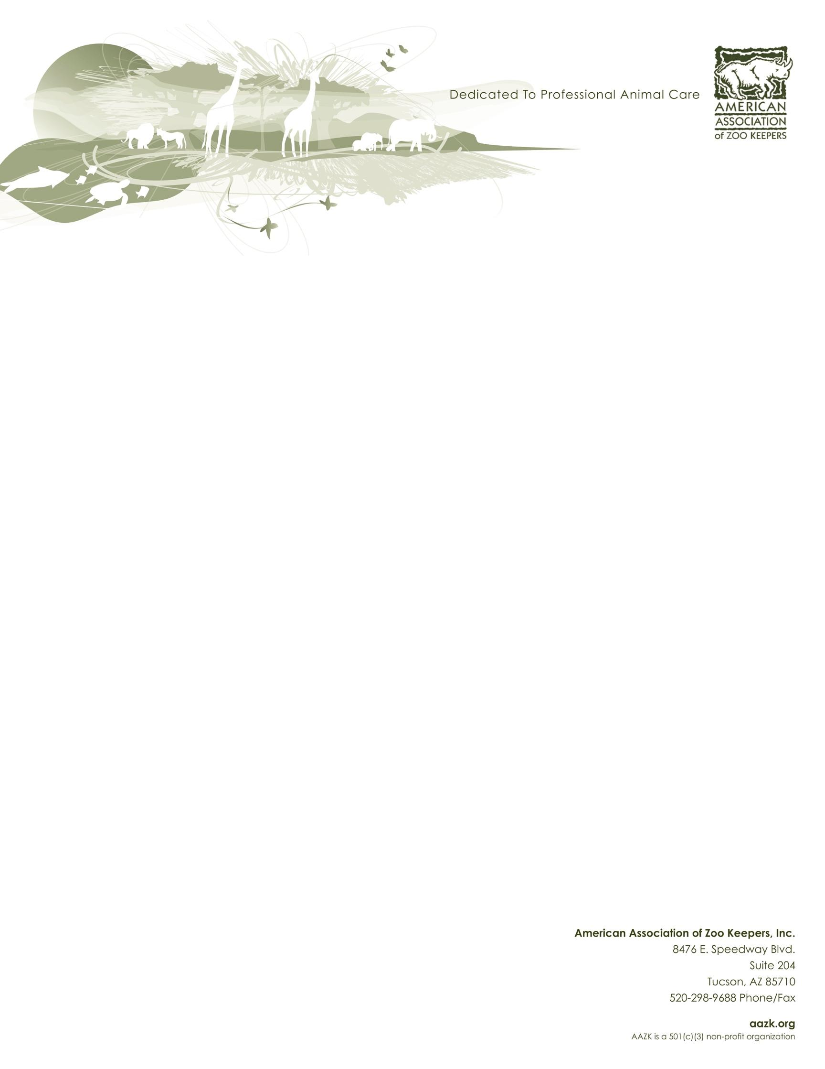

National Zoo Keeper Week 2019
Keeping it Real: A Keeper’s Life Beyond the Dirt
Dear AAZK Chapter,

It’s time to start thinking about National Zoo Keeper Week (NZKW) 2019. This year we will be focusing on education and clarification of what animal care professionals really do. We would like to acknowledge those common myths about the zooquaria field and put them to rest! Not only will we be acknowledging them, we will be providing tools to help you communicate the true life of our profession. To better prepare AAZK Chapters and facilities for the week, the NZKW Program created this planning packet to aid in your success. Additionally, over the next few months we will be asking YOU what it is you would like the general public to know more about our field. We invite you to think about what it is that few people know: What I really do on a daily basis. The species I help outside of my job. My level of education. What I do for conservation.

During NZKW, AAZK’s social media will also commit days to specific topics: in situ (field) conservation, ex-situ conservation (breeding, incubation, etc.), training, enrichment, education & public outreach, animal husbandry, and some of our favorite animal stories. What more should everyone know about these facets of zooquaria? We need you to share your stories with us to better engage the public – it’s up to you to make NZKW 2019 our most successful (and informative) year yet! This informational packet will not only help you prepare for NZKW, but also guide you through the process of sharing your stories, photos, and achievements of your team.

In this official planning packet, we have included a press release to provide your facility, ideas for chapter activities to help with education and recognition, a guide to AAZK’s social media campaigns, and printable selfie papers. These elements can be used via social media and beyond to show the world how you are #KeepingItReal, in what way you can recognize your peers, and how you’re celebrating NZKW. Please look for this packet to be updated annually; it will be sent out via email and available on the AAZK website.

The NZKW Program and AAZK are here to help you make the most of National Zoo Keeper Week! As it is every year, this week is dedicated to sharing the passion and devotion of keepers to the world!
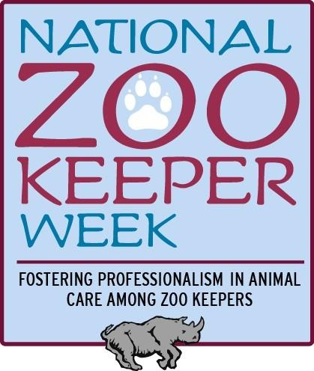
Sincerely,

Kristen Scaglione
NZKW Program Manager
kristen.scaglione@aazk.org

Jenna Schmidt
NZKW Program Vice-Manager
animalia.carnivore@gmail.com

Table of Contents
Celebrating Zoo Keepers’ Strength in Numbers 3
Press Release 3
National Zoo Keeper Week 2019 Programming 4
Social Media Campaigns 4
Setting the Record Straight 4
Share Your Selfie! 5
Infographics 5
Postcard Exchange 6
National Zoo Keeper Week #ImAKeeper Graphics: 6
Other Programming 7
About the American Association of Zoo Keepers and National Zoo Keeper Week 8
Fact Sheet 8
What is National Zoo Keeper Week? 8
What is the AAZK Resource Committee? 8
When is National Zoo Keeper Week? 8
What is the theme of NZKW this year? 9
Who should you contact with questions? 9
What has NZKW done in the past? 9
Why is there a National Zoo Keeper Week? 9

Celebrating Animal Keepers’ Strength in Numbers

Press Release

In order to further explain the work of keepers, in addition, the work of all zooquaria staff, AAZK will be showcasing the behind the scenes skills, knowledge and accomplishments with the theme “Keeping it Real: A Keeper’s Life Beyond the Dirt” for 2019’s National Zoo Keeper Week.

Tucson, AZ – July 21, 2019

In recognition of dedicated animal care professionals, the American Association of Zoo Keepers (AAZK) and zooquaria across the nation are celebrating National Zoo Keeper Week from July 21-27. AAZK is continuing its successful #ImAKeeper social media campaign, which promotes professionalism and the dedication to conservation shared by all keepers. This year, AAZK is introducing #KeepingItReal, to showcase the little-known facets of the animal care professions, as well as shed light on common keeper myths.

AAZK is made up of thousands of individuals whose work is invaluable, which is why in 2007, Congress decided to devote a full week to recognizing the contributions keepers bring to the care and conservation of wildlife and wild places – National Zoo Keeper Week. Keepers accomplish amazing things, contributing more than $800,000 to 357 conservation organizations in 2017 alone. Using their own time and money, keepers have kept this national organization growing for over fifty years, raising millions of dollars for rhino conservation. Despite these things, their stories often go untold. Therefore, National Zoo Keeper Week 2019 empowers AAZK members across the country to come together and promote their field with the new social media campaign of #KeepingItReal. The campaign will showcase the theme of this year’s NZKW, "KeepingItReal: A Keeper’s Life Beyond the Dirt." The focus will be on the backgrounds of zooquaria professionals, how they provide excellent standards of animal care, and what they do for conservation around the world.

AAZK invites all zoos, aquariums, and their guests to support this year’s National Zoo Keeper Week celebrations by following The American Association of Zoo Keepers on Facebook, Twitter (@AAZKINC) and Instagram (@aazkinc) and sharing the posts with their social networks. By supporting AAZK, zooquaria and their guests can help promote the important work of animal care professionals across the country and around the world – and contribute to wildlife conservation at large.

Current AAZK President, Bethany Bingham, shares "Each of us brings a unique blend of passion and skill when we enter the field of animal care. Our growth as animal care professionals coincides with developing specialties and contributing to wildlife conservation, both locally and globally. A career as a keeper is not defined by the dirt on our boots, but in the opportunities in which we wore them."

This July, join AAZK and their members across the country by following and posting #ImAKeeper, #KeepingItReal, and #NZKW2019 across social media.

National Zoo Keeper Week 2019 Programming

Social Media Campaigns
#NZKW2019 #ImAKeeper #KeepingItReal

During the past four years, NZKW has started using hashtags to engage and connect AAZK’s followers on social media with keepers across the country. This year, NZKW asks that you utilize official hashtags of National Zoo Keeper Week to continue that trend! By using these tags across social media platforms (Facebook, Twitter, Instagram, etc.), posts will be connected and easier to search for and share. Both of AAZK’s social media pages on Facebook and Twitter will continue to share your photos and posts about NZKW this year, and further elevate the impact of the animal care field. While keeper appreciation week and similar terms are frequently utilized, the current goal of the NZKW program is to go beyond appreciation and move towards professional recognition. As such, AAZK wholly encourages the use of the unified NZKW hashtags and titles.

Setting the Record Straight
The NZKW team invites you to boast about your skills, accomplishments and hard work, whether that be you, your team, your AAZK Chapter or your animal care department as a whole. Share your stories with us and we will share them with the world. We will be creating resources to help your reach out to non-zoo professionals on topics such as: keeper education level, salary, public outreach, training & enrichment, husbandry, and conservation involvement (in situ & ex situ).

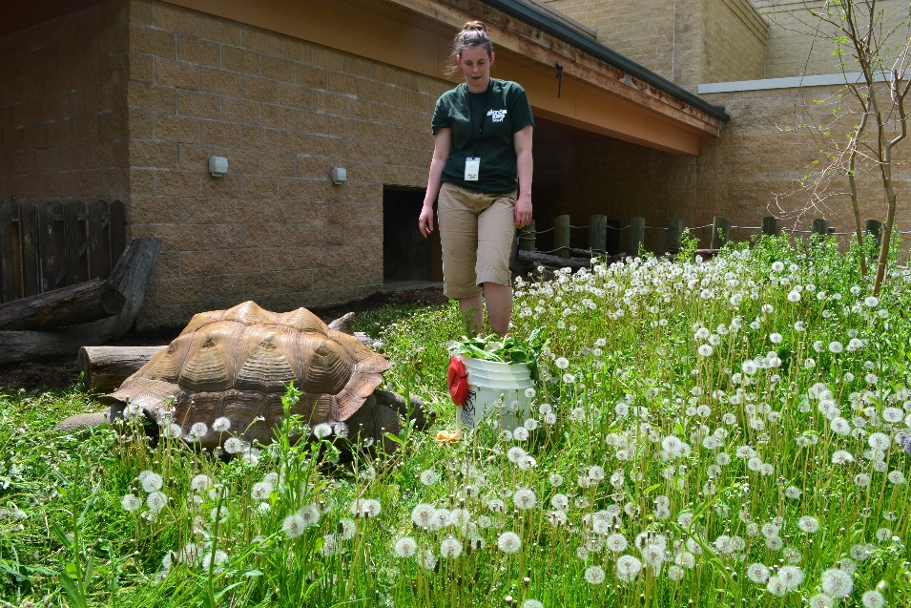

Share Your Selfie!
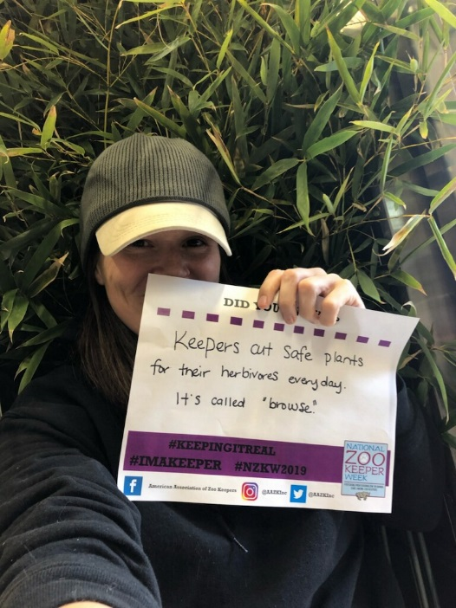
Please download the PDF attached to the NZKW planning packet email with printable “selfie” pages (entitled SelfiePrintable__DidYouKnow_NZKW2019.pdf). You are encouraged to print the pages out on recycled paper or other materials, and fill them in with words or statements that you think complete the provided text.

Get creative! Take selfies (or regular photos) during your daily duties at work, with the animals you care for, or doing research in the field – and always remember to follow the social media policies of your facility or company. Share your images to the AAZK Facebook page (American Association of Zoo Keepers) or on Twitter (@AAZKinc) with any (or all!) of this year’s hashtags. AAZK will share selected images in the weeks leading up to NZKW - you may even see a few familiar faces from your favorite committees and the AAZK Board of Directors!

Please note, by sharing a photo with AAZK you’re acknowledging the following:

I hereby grant the American Association of Zoo Keepers permission to use my likeness in a photograph in any and all of its publications, including website entries, without payment or any other consideration. My permission indicates that my host institution has granted permission for the release of this photograph. I understand and agree that the image will become property of the American Association of Zoo Keepers. I hereby irrevocably authorize the American Association of Zoo Keepers to edit, alter, copy, exhibit, publish, or distribute this photo for purposes of publicizing the American Association of Zoo Keeper’s programs on social media, first and foremost for the promotion and educational value of the zoo keeping profession, but also for any other lawful purpose. In addition, I waive the right to inspect or approve the finished product, including written or electronic copy, wherein my likeness appears. Additionally, I waive any right to royalties or other compensation arising or related to the use of the photograph. I hereby hold harmless and release and forever discharge the American Association of Zoo Keepers from all claims, demands, and causes of action which, I, my heirs, representatives, executors, administrators, or any other persons acting on my behalf of my estate have or may have by reason of this authorization. I am 21 years of age and am competent to contract I my own name. I have read this release before submitting a photo, and I fully understand the contents, meaning, and impact of this release.

Postcard Exchange
Consider truly making it a National Zoo Keeper Week by participating in the AAZK Resource Committee’s (ARC) chapter postcard exchange! Connect with chapters across the nation and share how your chapter is celebrating team work in the zoo keeping profession! Between June 1st and July 21st, participating chapters will send cards to fellow chapters wishing them a “Happy NZKW!”
To enroll in the exchange, contact NZKW@aazk.org with your chapter's current mailing address, along with the name of the chapter member who is granting permission to share. Enrollment response should be sent no later than June 30th.
All enrolled chapters will both send a card to a randomly assigned chapter and receive a card from another chapter. Cards should be from either your chapter or affiliated institution. Gifts of any sort should not be sent; this project is meant to connect chapters rather than exchange goods.
The random assignments of receiving chapters will take place upon registration. Participants will receive the name and mailing address of their assigned chapter via e-mail and will be required to have their cards sent no later than July 21st.

National Zoo Keeper Week #ImAKeeper Graphics:
During the past four years, the NZKW Program has created word clouds to emphasize the diversity of the animal care profession, both in title and in job description. With the previous generations of word clouds, AAZK and NZKW recognized how keepers were (and still are) much more than skilled laborers – they are complex problem solvers in an ever changing profession. This was done by creating dynamic word clouds shaped in varying species, tools and phrases. The tradition will continue this year as shapes YOU requested at last year’s AAZK Conference will come to life. Watch for the new series of word clouds on AAZK’s social media pages.

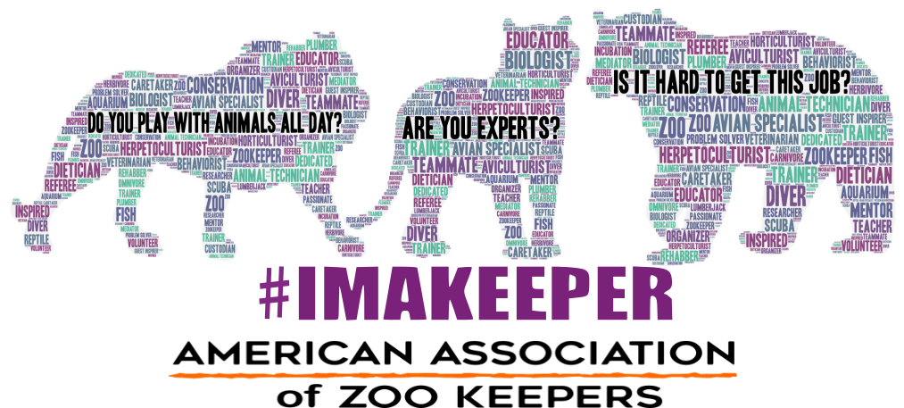

Other Programming
Every year, NZKW strives to bring the best of AAZK and the animal care profession to you, your chapter, and your facility. This year is no different! The NZKW Program has a few other things on deck to promote keepers… check your social media feeds this spring!

About the American Association of Zoo Keepers and National Zoo Keeper Week

The American Association of Zoo Keepers is a non-profit volunteer organization made up of professional zoo keepers and other interested persons dedicated to professional animal care and conservation. AAZK’s mission is to advance excellence in the zoo keeping profession, foster effective communication beneficial to animal care, support deserving conservation projects, and promote the preservation of our natural resources and animal life. For more information, visit www.aazk.org.

National Zoo Keeper Week promotes the dedication and hard work of animal care professionals year round, celebrates animal care professionals’ achievements during the third week in July, shares the accomplishments of AAZK Chapters, creates awareness of AAZK Chapters’ dedication to conservation and wildlife to the public, and communicates the necessity for zoos and aquariums by way of animal care professionalism, research, and fundraising efforts.

Fact Sheet

What is National Zoo Keeper Week?
An AAZK national program to recognize and promote dedicated zoo and aquarium professionals year round, culminating in an annual week of recognition during the third week in July.

Purpose: The National Zoo Keeper Week Program exists to provide members with the tools and support to recognize their peers and promote the animal care profession during National Zoo Keeper Week and throughout the year.
Vision: The National Zoo Keeper Week Program will connect the public with animal care professionals in the name of raising awareness of what animal care professionals do year-round, recognizing their hard work, conservation efforts, and passion.
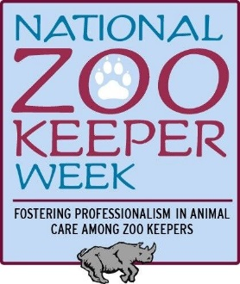
Mission: The National Zoo Keeper Week Program will provide tools and resources for the members that promote the animal care profession and educate the general public, each year finding innovative and novel ways of doing so.

When is National Zoo Keeper Week?
National Zoo Keeper Week begins annually on the third Sunday of July. Remember – it’s never too early (or too late) to start planning for NZKW; check out the dates for upcoming years:

July 21-27, 2019
July 19-25, 2020
July 18-24, 2021

What is the theme of NZKW this year?

In acknowledgement of the team work it takes to care for animals and their wild counterparts, the 2019 NZKW theme is Keeping it Real: A Keeper’s Life Beyond the Dirt

Who should you contact with questions?
Kristen Scaglione
NZKW Program Coordinator
kristen.scaglione@aazk.org

What has NZKW done in the past?
National Zoo Keeper Week has focused on the diversity of zooquaria professionals – in what they do on a daily basis to what they do with their whole careers. These have been highlighted by posting daily keeping facts, chapter spotlights and inviting chapters across the country to share their stories. Chapters have shared their photos, activities, and events with AAZK National in order to bring zoo and aquarium staff together. NZKW has grown over the past couple years as more and more chapters get involved! Past themes of ‘Keepers Care’ and ‘Golden Keepers’ kept the focus on the above and beyond work keepers do for conservation both inside and outside their facilities. This year NZKW is no longer an entity of the AAZK Resource Committee, but an entirely independent program. It will be focusing on education more than ever before and expanding its programming to be year-round in addition to the annual week in July. NZKW will be focusing on the little known sides of the animal care profession, as we share the little known facts by “Keepin’ it Real”

Why is there a National Zoo Keeper Week?
As the need to protect and preserve wildlife and their vanishing habitats continues to increase, the animal care professional’s role as educators and conservation ambassadors has become essential. Zoo and aquarium professionals care for hundreds of species, including mammals, birds, reptiles, amphibians, fish, and invertebrates.

Three hundred and sixty-five days a year, twenty-four hours a day, seven days a week, in all weather (from hurricanes to blizzards, to heat waves, and everything in between), keepers have to be ready for anything. They are involved in captive animals’ lives and welfare from birth to death and every moment in between, and often create lifelong bonds. A keeper’s day can include an array of tasks including cleaning, food preparation and feed out, medical treatment, training, enrichment, landscaping, exhibit design, animal introductions, public outreach and education, and much MUCH more.

Most animal care professionals have bachelor degrees or higher, many with advanced degrees, and continue to advance their education by attending workshops, conferences, and certificate programs annually. They are not just skilled laborers, but professionals who continue to expand their knowledge of an ever-advancing field. Working with animals requires constant complex problem solving and progressive learning. Beyond their daily duties, keepers are involved in research projects, field work, and conservation organizations.

But, in the end, being a zoo keeper, aquarist, aviculturist – whatever you call it, they’re all animal care professionals, and it is more than just a job. It’s a career; it’s a passion, it’s a calling. THAT’S why we recognize zoo keepers year round, and THAT’S why we have a week dedicated to promoting their skills, dedication, and enthusiasm for wildlife to world. Join AAZK every third week in July, to celebrate National Zoo Keeper Week!
Representative Susan A. Davis introduced House Resolution 509 on June 21, 2007:
This resolution was proposed to encourage individuals on a national level to engage in programs, activities, and ceremonies during National Zoo Keeper Week which encourage species conservation and public awareness of the important role of zoos in wildlife conservation.
“Expresses support for the goals and ideals of National Zookeeper Week. Recognizes the contributions zookeepers make to the care and conservation of captive exotic animals and to research, public education, and recreation. Expresses a renewed dedication to the appreciation and preservation of animal wildlife and nature and an invigorated effort to foster conservation projects and increase awareness of the need for preservation.”

