FOR IMMEDIATE RELEASE:

MEDIA CONTACTS:

Carlotta Stankiewicz, 512.475.6784, carlotta.stankiewicz@blantonmuseum.org
Penny Snyder, 512.471.0241, penny.snyder@blantonmuseum.org

Blanton Museum of Art Presents Ed Ruscha: Drum Skins

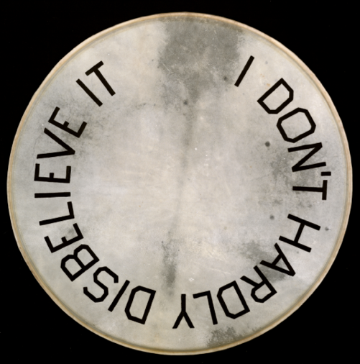

New Body of Work Explores Southwestern-Inspired Vernacular

AUSTIN, TX—December 19, 2019—The Blanton Museum of Art will present Ed Ruscha: Drum Skins in its Contemporary Project gallery from January 11 to July 12, 2020. The exhibition will debut a new body of more than a dozen round paintings made between 2017 and 2019 by the iconic American artist known for his use of language.

“We are honored to present a new body of work by one of today’s most significant artists, Ed Ruscha, in the Blanton’s Contemporary Project, a rotating program for innovative work,” said Blanton director Simone Wicha. “Drum Skins brings Ruscha’s distinctive observations about American vernacular and culture to a new medium. With bold typography, allusions to music, and Southwestern speech, Drum Skins is certain to appeal to our audiences here in Austin.”

The installation includes 13 text-based works painted on drumheads, which Ruscha has collected over the past 40 years. Most of the paintings feature phrases with double and triple negatives such as “Not Never,” “I Can’t Find My Keys Nowhere,” and “I Don’t Hardly Disbelieve It.” Ruscha attributes these phrases to spending his childhood in Oklahoma, noting that “I grew up with people that spoke this way.…I was very acutely aware of it and amused by it.” They are all printed in his signature font, which he refers to as “Boy Scout Utility Modern.” Several feature phrases overlaid on a mountain, a common visual motif in Ruscha’s works.

“Ruscha’s new drum paintings feel quintessentially American to me,” said Veronica Roberts, Blanton Curator of Modern and Contemporary Art and organizer of the exhibition. “In these paintings, he has turned words into beguiling landscapes that capture the distinctive qualities of vernacular Southwestern speech. I’m particularly excited by his exploration of drumheads. In addition to offering new compositional opportunities for his text-based practice, the drums conjure the rich Native American traditions of art made on animal skins and the history of brass bands and marching bands in the United States.”

For the past six decades, Ruscha has explored the complex relationship between images and text. As a young artist in Los Angeles, he developed a fascination with typography when he worked as an apprentice setting type for a printing press: “somehow [it] led me off on this path, almost like a bumper car…. The idea of poetry, a selection of oddities of words, strange or double meanings, became my interest. I began to see that painting words was a real thing, a legitimate subject matter.”

The Blanton has four lithographs by Ruscha in its encyclopedic collection of prints and drawings, as well as two book projects produced by Lawrence Weiner in collaboration with Ruscha. The Harry Ransom Center, also on the campus of The University of Texas at Austin, holds the Edward Ruscha Papers and Art Collection. With materials from 1962 to 2015, this partial archive includes complete documentation of select artist’s books, commissioned works, and print projects; most notably materials related to the making of Ruscha’s artist’s book of Jack Kerouac’s On The Road and materials relating to Twentysix Gasoline Stations (1962), Every Building on the Sunset Strip (1966), and Some Los Angeles Apartments (1965).

Ruscha is the sixth artist to have a solo exhibition in the Blanton’s Contemporary Project gallery. Begun in 2017, the Contemporary Project presents recently made work by contemporary artists, organized by various curators at the museum. The next Contemporary Project will feature work by Diedrick Brackens. Past artists that have exhibited in the Contemporary Project include Vincent Valdez, Lily Cox-Richard, Clarissa Tossin, and Kambui Olujimi.

This exhibition is organized by Veronica Roberts, Curator of Modern and Contemporary Art.
Generous funding for this exhibition is provided by Jeanne and Michael Klein, with additional support from Ellen and David Berman.

Public Program:
Artist Talk: Ed Ruscha in conversation with Blanton curator Veronica Roberts on Thursday, May 7 at 6:30pm.

###

About Ed Ruscha:
Ed Ruscha was born in Omaha, Nebraska in 1937, and raised in Oklahoma City, Oklahoma. In 1956, he moved to Los Angeles to attend Chouinard Art Institute (now Cal Arts) and has since lived in Los Angeles. Ruscha’s practice, which spans drawing, painting, photography, film, printmaking, and publishing, reframes American vernacular language and landscape in an experimental formal context. He is well known for his artist’s books, such as Twentysix Gasoline Stations (1963), as well as his paintings with words as their subject. His work is in museum collections across the globe and he has been the subject of major retrospectives at prestigious institutions worldwide.

About the Blanton:
Austin's art museum sits at the crossroads of The University of Texas at Austin campus and downtown, where it welcomes more than 200,000 visitors annually. Renaissance and Baroque paintings, Latin American art from the 1500s to the present, and modern and contemporary art from across the world are among the highlights of its permanent collection, which boasts around 19,000 objects. This includes Austin by Ellsworth Kelly, the iconic building and work of art that opened in February 2018 to great acclaim. The museum presents several large-scale traveling shows each year, as well as contemporary installations, film and video displays, and exhibits drawn from its comprehensive collection of prints and drawings. From artist talks to performances by Austin's renowned musical talent, the Blanton also offers public programming that engages, educates, and entertains year-round.

Image credit:
Ed Ruscha, I Don’t Hardly Disbelieve It, 2018, acrylic on vellum drumhead, diameter 30 3/4 inches x 1 inch depth. Photo: Paul Ruscha, courtesy of the artist and Gagosian

