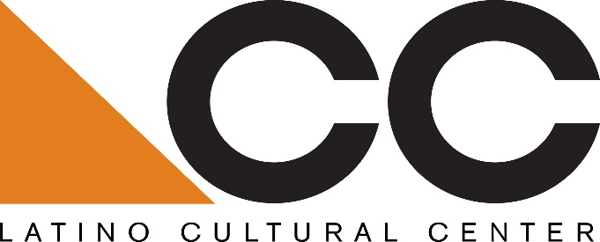

Call for Visual Arts Exhibition Proposals:
The Latino Cultural Center is seeking proposals from Dallas-based Latino/a arts, cultural, and/or heritage organizations for a Hispanic Heritage Month exhibition at the center from September 13 – October 12, 2019.
Eligibility:
Preference will be given to Dallas-based ALAANA* visual artists, arts, cultural, and/or heritage organizations, and/or artistic collectives that have planned Latino/a arts, cultural, and heritage programs in Dallas and/or Texas in the past few years.
Submission guidelines:
Please submit a minimum 150-word description with a fee proposal, including organizational mission, proposed artist(s), and previous experience working with Dallas and regional Latino/a arts and cultural venues and/or organizations. All proposals must be submitted to Benjamin Espino, Manager, Latino Cultural Center via email: benjamin.espino@dallascityhall.com.
Submissions will be accepted beginning Friday, March 29, 2019
Submission Deadline: Thursday, April 4, 2019
Selected candidate will be notified by email on April 15, 2019
About the Latino Cultural Center:
As a division of the City of Dallas’ Office of Cultural Affairs, the mission of the Latino Cultural Center is to serve as a regional catalyst for the preservation, promotion and development of Latino/a and Hispanic arts and culture. Designed by internationally recognized Mexican architect Ricardo Legorreta, the 27,500 square foot facility features a 300-seat auditorium, outdoor plaza, and two galleries spaces.
OCA vision: An equitable, diverse, and connected community, whose residents and visitors thrive through meaningful arts and cultural experiences in every neighborhood across Dallas.
https://dallasculture.org/
*ALAANA: African, Latinx, Asian, Arab, Native American

